**Evidence for Project Unit**

Name: Olga Maunsell

Cohort: E18

**P1 – Contributors page – Group project**

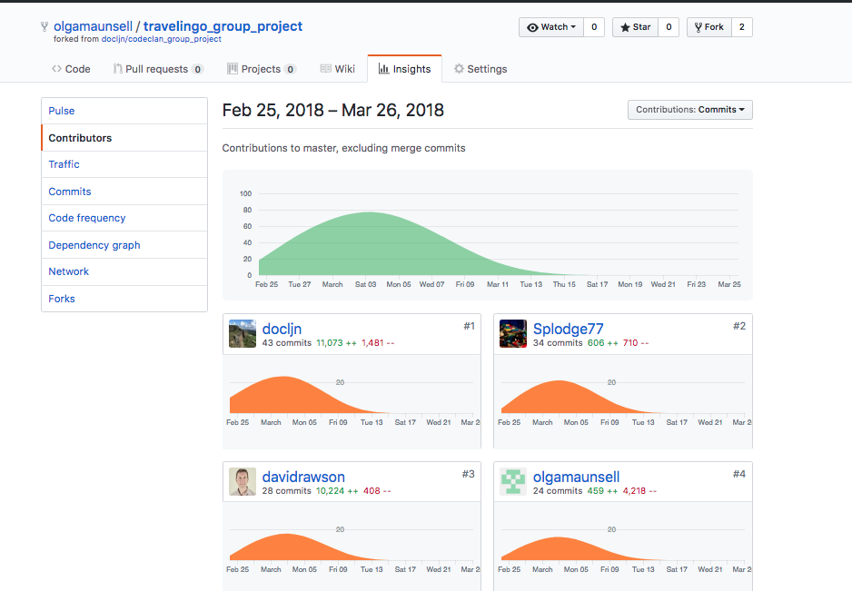

**P2 – Screenshot of project brief – Group Project**

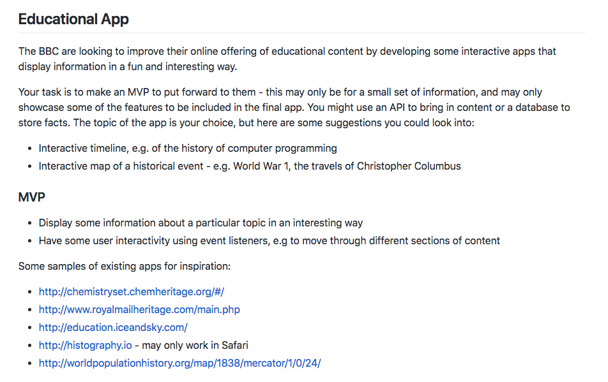

**P3 – Planning – Group Project**

Start of group project

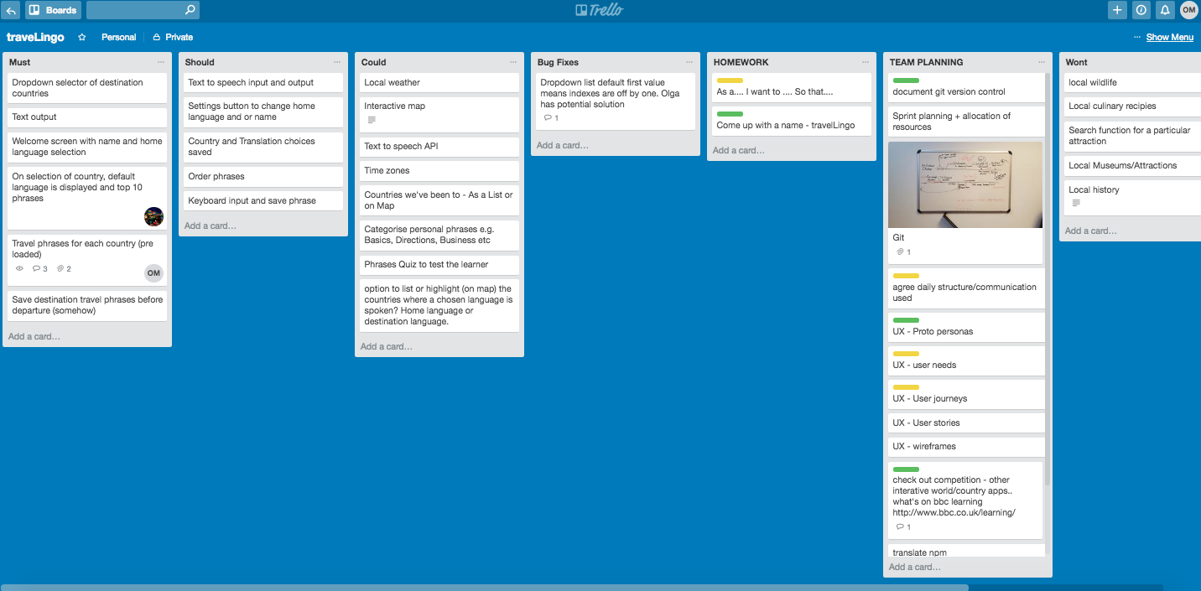

End of group project

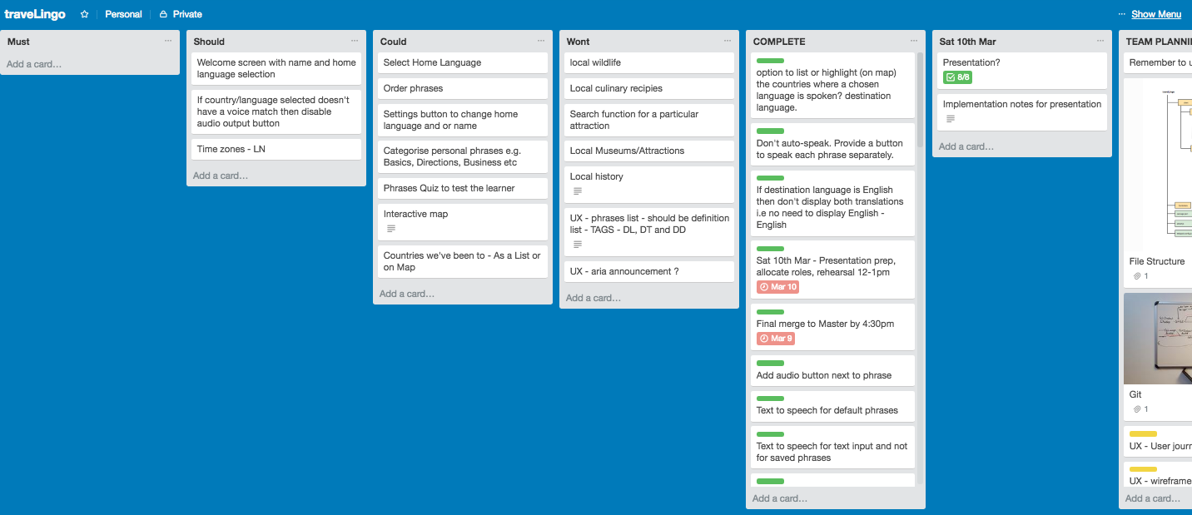

**P4 – Money Tracker App – Acceptance Criteria and Testplan**

|  |  |  |
| --- | --- | --- |
| **Acceptance Criteria** | **Expected Result/Output** | **Pass/Fail** |
| An option is provided to add a new transaction | When a user selects “New Transaction” a new screen will appear allowing user to enter Vendor, Tag, Amount, Date, Comment and save the transaction | Pass |
| When a user enters and saves a transaction, transaction is created and can be viewed in the transaction list. | When user enters transaction details and saves transaction a message “Transaction created” is displayed. The new transaction is now also displayed on the main transactions screen. | Pass |
| When a user enters a transaction but does not select the save button, the transaction is not saved | Transaction is not saved.  Transaction is not displayed on the main transactions screen. | Pass |
| User can view all transactions added | The main transactions screen lists all transactions added by the user in descending date order | Pass |
| User can view total amount of all transactions | The total amount of all transactions is displayed to 2 decimal places at the bottom of the transactions list. | Pass |
| User can select an individual transaction | User can select a transaction from the main transactions screen , a new screen will appear displaying the transaction details with options to edit or delete | Pass |
| User can edit a transaction | When user selects to edit a transaction a new screen is displayed allowing user to edit and update transaction details. On update the main transaction screen will display the new details. | Pass |
| User can delete a transaction | When user selects to delete a transaction, the transaction is deleted. The transaction can no longer be viewed on the main transactions screen | Pass |

**P5 – User Site Map – Money Tracker App**

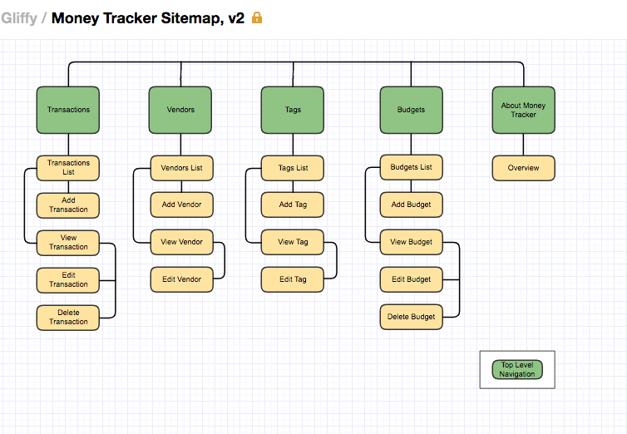

**P6 – Two Wireframe Designs – Money Tracker App**

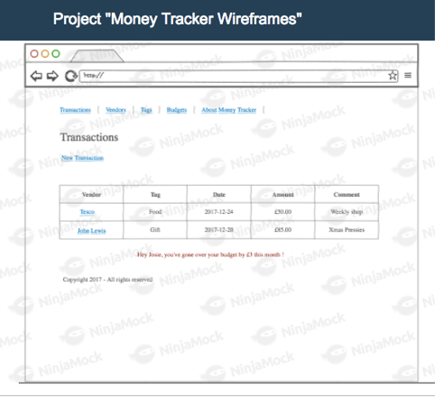

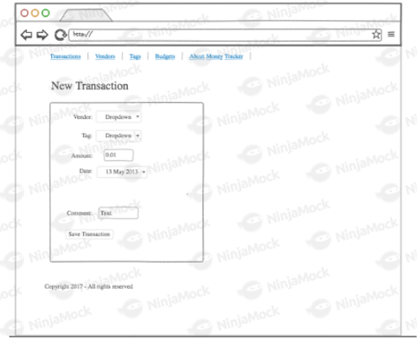

**P7 – System Interaction Diagrams**

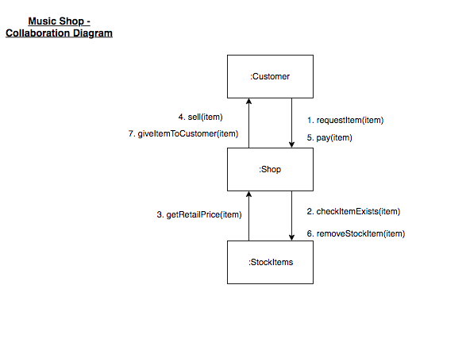

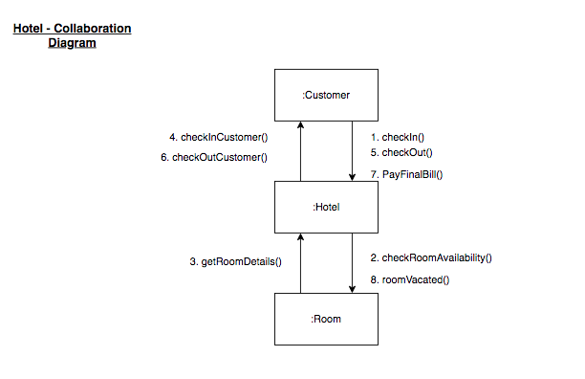

**P8 – Object Diagrams**

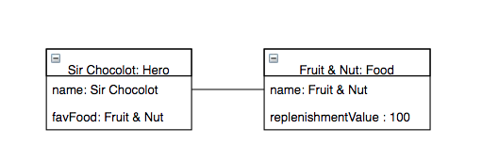

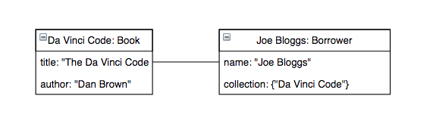

**P9 – 2 Algorithms**

<https://github.com/olgamaunsell/week_11_day3_enumeration_hw>

I chose this as the code is easy to follow, so good for another coder to understand. This function’s purpose is to find duplicate values in array, returning a new array of the duplicates

The function has 2 algorithms:

1. Creating a countHash – the code loops through the array, for each number in the array if the number doesn’t exist in the hash the number is added to the hash with a value of 1 otherwise if it exists the value is incremented by 1.
2. Builds a new duplicatesArray – the code retrieves the keys of the countHash, for each key it checks if the key’s value > 1 i.e. it’s a duplicate and if so it puts the number in the duplicates array. The duplicates array is returned by the function.

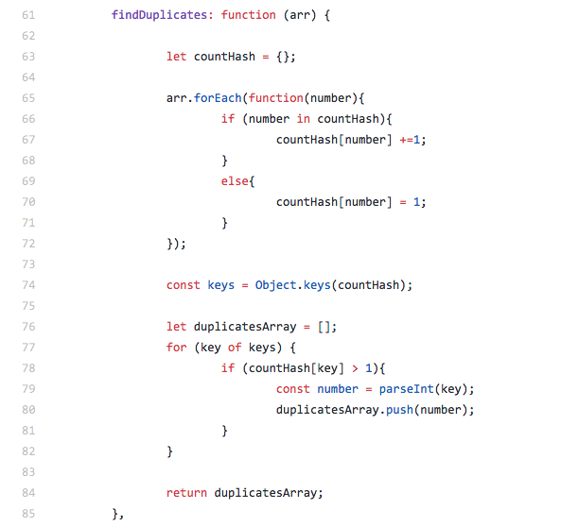

Test

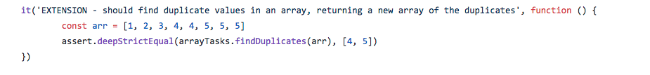

**P 10 - An example of pseudocode for a function**

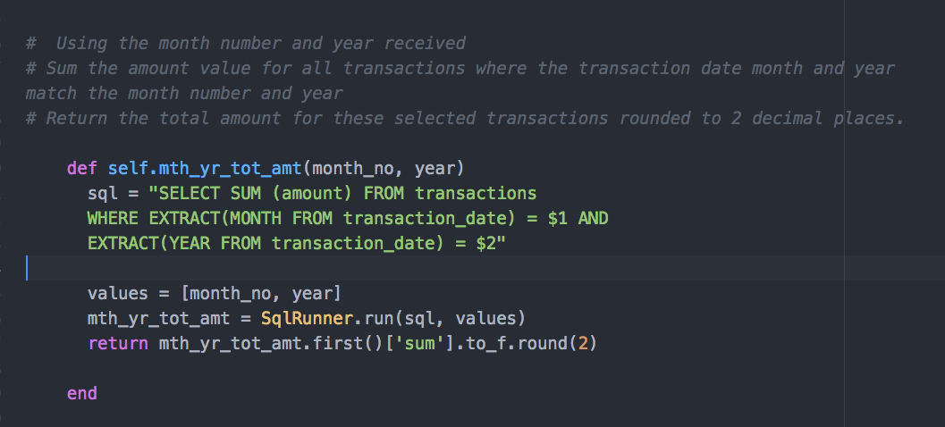

**P11** – Screenshots of my 2nd Individual project - a to do list app I called “ICanDoItList”

https://github.com/olgamaunsell/ICanDoItList-Java-Android-App

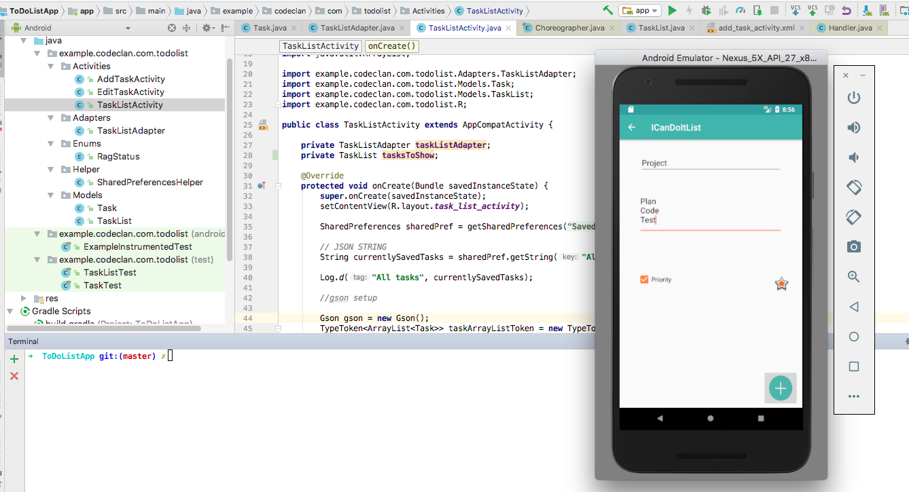

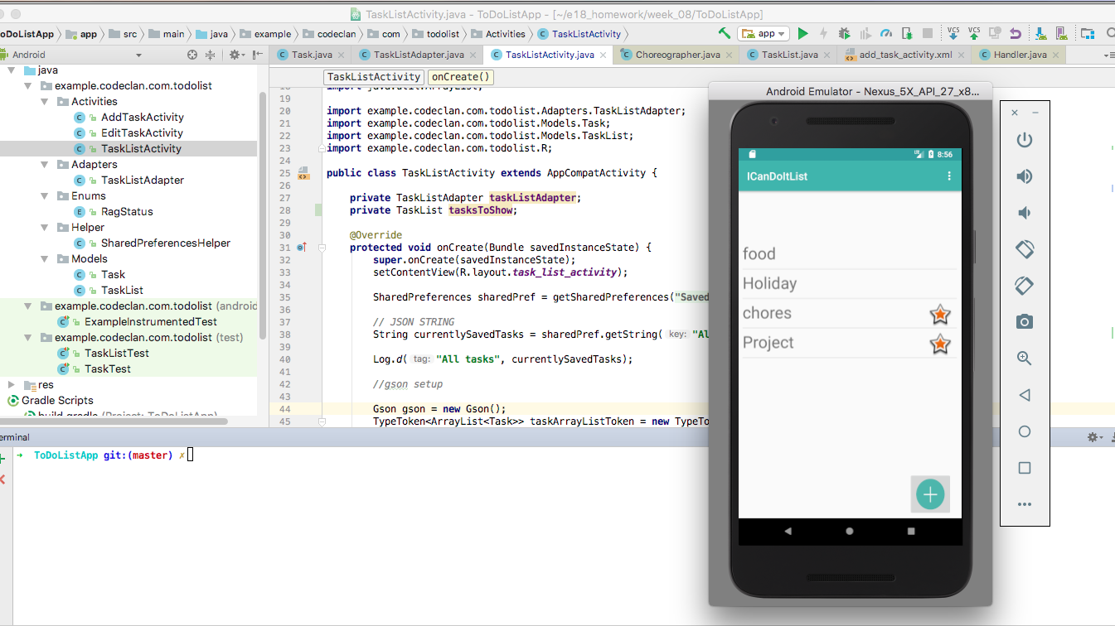

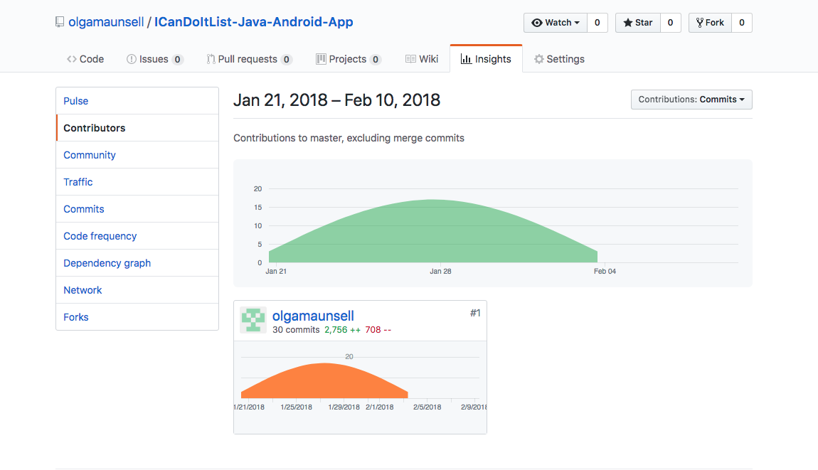

**P12 – Screenshots of planning and the different stages of development to show changes**

Day 2 of individual Java Android Studio project (27th Jan)

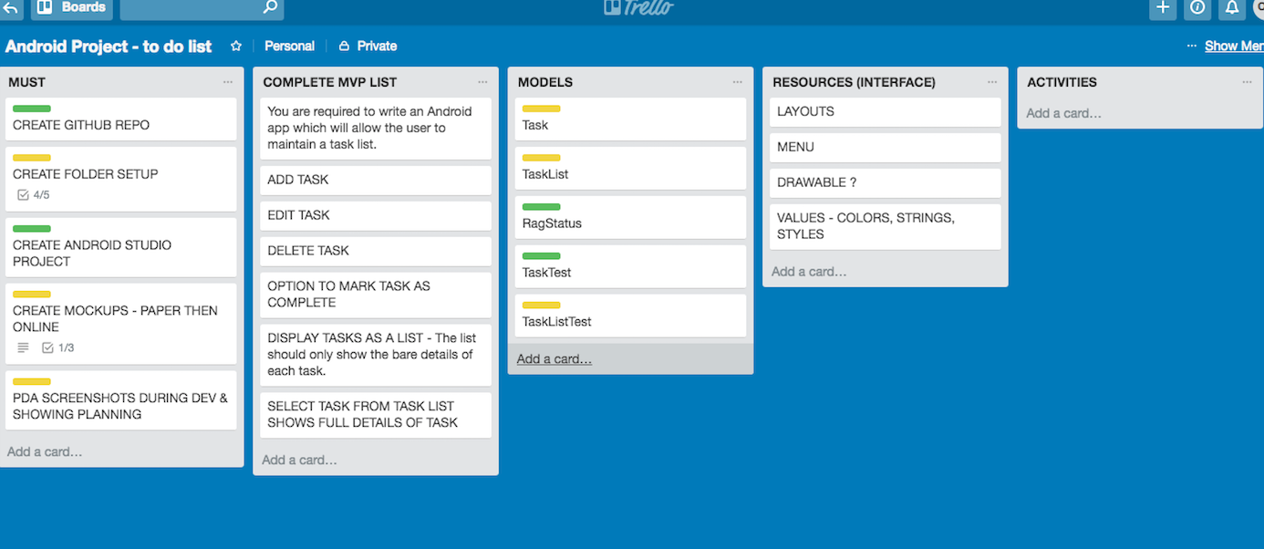

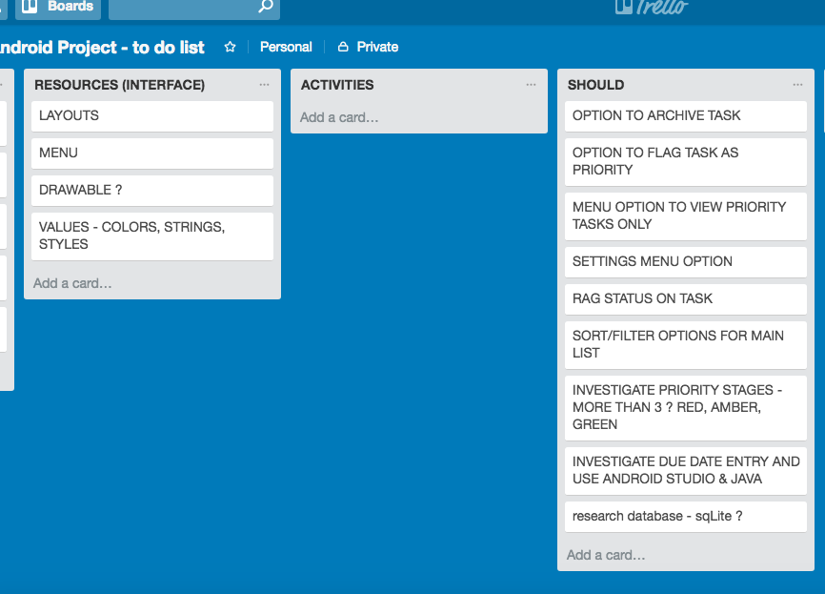

During the project week I decided after research not to include “completed task” checkbox on Main List screen – too complicated/difficult to do with Shared preferences – this would be better with a database as a future extension.

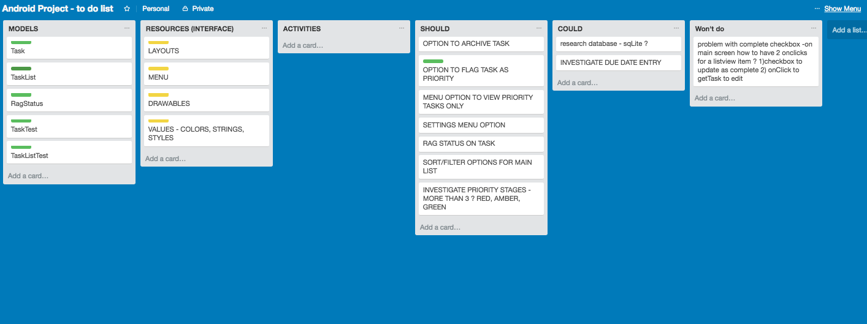

P12 (Continued) - Wed 31st Jan 2018 - Updated plan on last Day

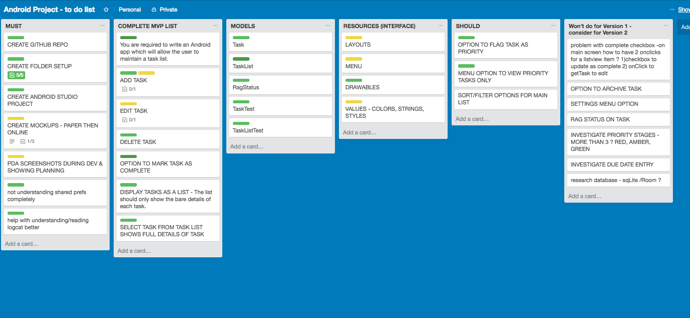

**P13 – User input being processed to design requirements.**

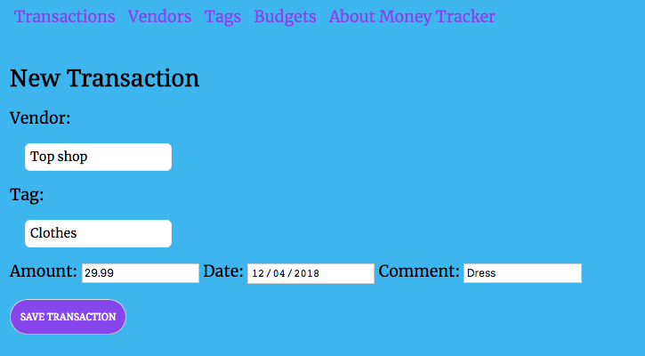

User input being saved – shows transaction has been saved and added to list of transactions – most recent “Dress” transaction at the top of the list.

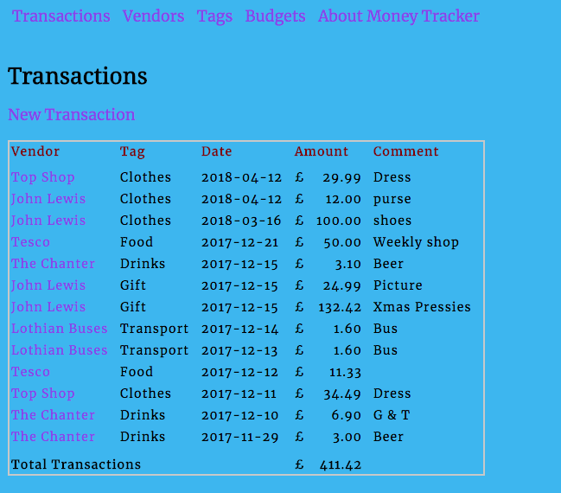

**P14 – Interaction with data persistence – data input in P13 saved to database**

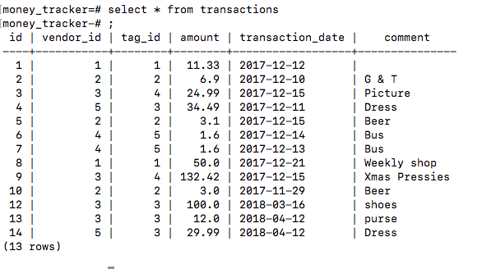

**P15 - User wishes to view budget details for April 2018 and clicks the “Budget details” link for that month**

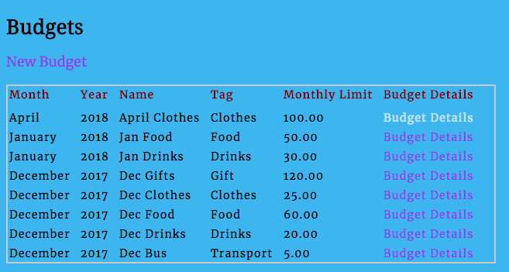

**Result** – user request being processed correctly – budget details for April 2018 displayed

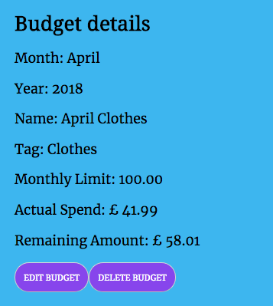

**P16 – Show an API being used within a program**

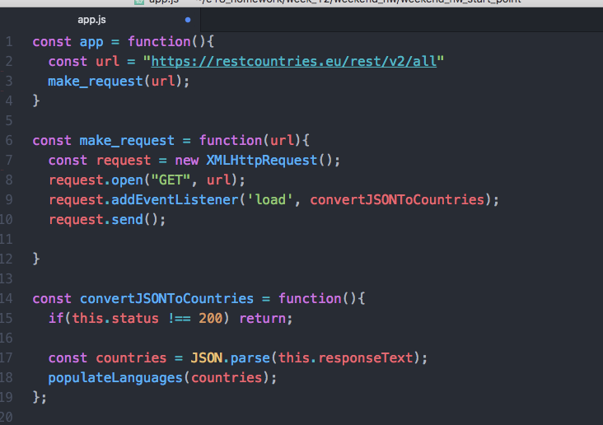

Part 1 of method populateLanguages

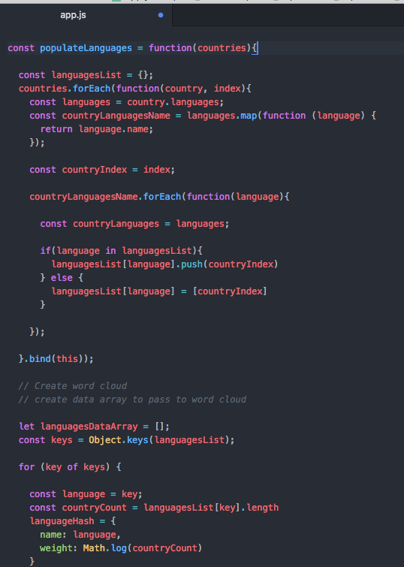

P16 (continued) - Part 2 of method populateLanguages

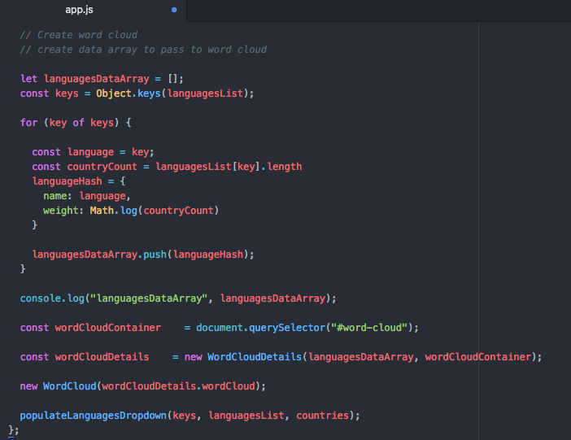

The API being used by the program whilst running

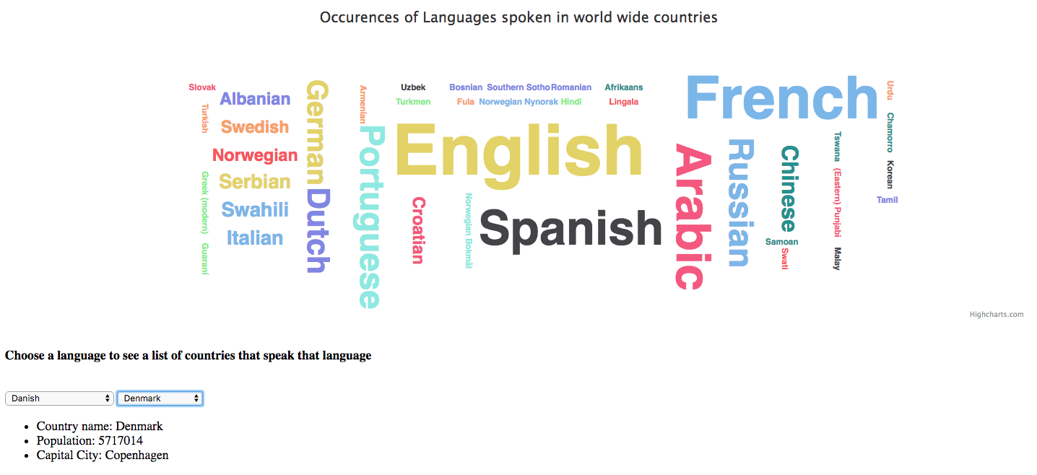

**P17 – Travelingo Project - Bug Tracking Report**

|  |  |  |  |
| --- | --- | --- | --- |
| **Issue** | **Status** | **Resolution** | **Status** |
| User can enter a phrase to be translated without selecting country/language first | Failed | Change order of user entry so that the country/language dropdown is selected first before user can enter a phrase | Pass |
| User can leave phrase blank and select submit to translate | Failed | Update validation to ensure user has entered a phrase. If user clicks submit without phrase entry then a message will appear prompting user to enter a phrase to translate. | Pass |
| Speak button is provided for languages where there is no voice synthesis | Failed | Update code validation and screen display to ensure that the speak button is not available for languages which there is no voice output e.g. Sri Lanka | Pass |
| User selects country with English as main language. This displays and translates from English to English which is not required. | Failed | Update code validation and when country language is English do not provide translation, only display Country weather, flag and where that language is spoken on world map | Pass |
| When phrase to be deleted contains a question mark, the phrase isn’t deleted | Failed | The ? is a special character so the code requires to be updated to use encodeURIComponent so that the phrase can be found in the database and deleted | Pass |

**P18 - Testing**

